Sql project on employees dataset

**Database-employees.**

**Tables :**

**Employees :** employee_id,first_name,last_name,email,phone_number,hire_date,job_id,salary,commission_pct,manager_id,department_id.

**department :**

department_id, department_name,manager_id,loaction_id.

**Locations :**

loaction_id,street_address,postal_code,city,state_province,country_id.

**job_history :**

employee_id,start_date,end_date,job_id,department_id.

**Jobs :**

job_id,job_title,min_salary,max_salary.

**Regions :**

region_id,region_name.

**countries :**

country_id,country_name,region_id.

SELECT * FROM employees;

SELECT * FROM departments;

SELECT * FROM locations;

SELECT * FROM jobs;

SELECT * FROM regions;

SELECT * FROM countries;

1. **Question**: Retrieve the names and email addresses of all employees who work in the 'Sales' department.

select e.first_name, e.last_name,e.email,d.department_name from emp e inner join departments d on e.department_id=d.department_id where d.department_name='sales';

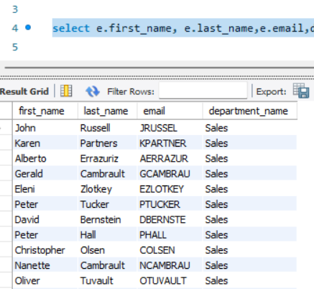

1. **Question**: Find the total number of employees in each department.

select d.department_name ,count(e.employee_id) as total_employees from emp e join departments d on e.department_id = d.department_id group by d.department_name;

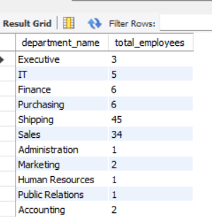

1. **Question**: Find the minimum, maximum, average salary of employees.

select avg(salary) as average,max(salary)as maximum,min(salary)as minimum from emp;

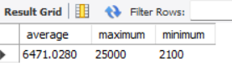

1. **Question**: Calculate the average, minimum, maximum salaries for each job title

SELECT j.job_title, AVG(e.salary) as average_salary, max(salary)as maximum, min(salary)as minimum FROM emp e JOIN jobs j ON e.job_id = j.job_id GROUP BY j.job_title;

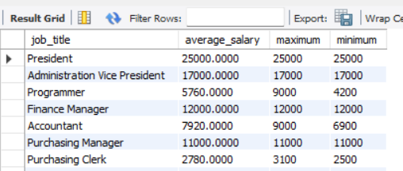

1. **Question**: Find the employee with the highest salary and display their details.

select * from emp where salary in(select max(salary) from emp) order by salary desc;



1. **Question**: Identify the countries where employees are located, along with the count of employees in each country.

SELECT c.country_name, COUNT(e.employee_id) AS employee_count

FROM emp e

JOIN departments d ON e.department_id = d.department_id join locations l on d.location_id=l.location_id

JOIN countries c ON l.country_id = c.country_id

GROUP BY c.country_name;

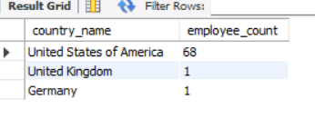

1. What is the total number of employees hired in each year?

select year(hire_date) as hire_year, count(employee_id) as total_employees from emp group by hire_year;

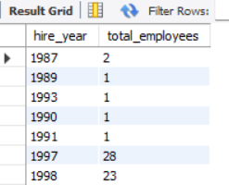

**Without using year:**

select hire_date,count(employee_id) as total_emp from emp group by hire_date;

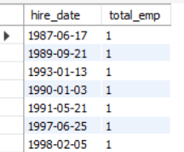

1. How many employees have a commission percentage greater than 0.1%?

select employee_id,first_name,commission_pct from emp where commission_pct > 0.1;

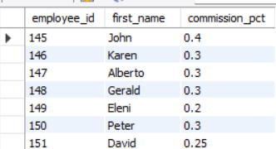

1. Total no.of cities and each city how many employess?

select l.city ,count(employee_id)from emp join departments d on emp.department_id=d.department_id join locations l on d.location_id=l.location_id group by l.city;

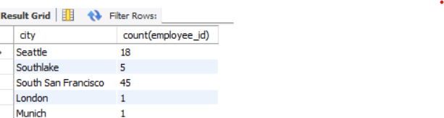

1. What is the average duration of employment for each department?

select d.department_id,d.department_name,round(avg(datediff(jh.end_date,jh.start_date))) as total_duration from job_history jh join emp e on jh.employee_id=e.employee_id

join departments d on e.department_id=d.department_id group by d.department_id, d.department_name;

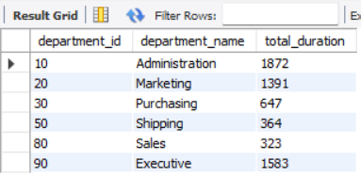

1. Can you provide a list of employees who have been hired within the last six months or 1 year?

SELECT employee_id,first_name,last_name,hire_date FROM emp

WHERE hire_date >= DATE_SUB((SELECT MAX(hire_date) FROM emp), INTERVAL 1 year) order by hire_date;

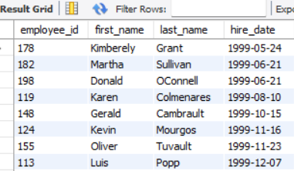

1. Can you provide a breakdown of employees by region?

SELECT r.region_name, COUNT(e.employee_id) AS total_employees FROM emp e

JOIN departments d ON e.department_id = d.department_id

JOIN locations l ON d.location_id = l.location_id

JOIN countries c ON l.country_id = c.country_id

JOIN regions r ON c.region_id = r.region_id

GROUP BY r.region_name;

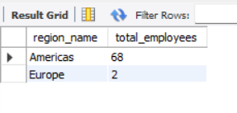

1. Can you list the employees who do not have a manager assigned to them?

select employee_id, first_name,last_name ,d.manager_id from emp left join departments d on emp.manager_id=d.manager_id where d.manager_id is null;

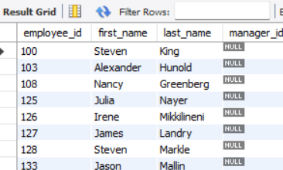

1. Can you identify any employees who have held multiple job titles simultaneously?

SELECT DISTINCT jh1.employee_id, e.first_name, e.last_name,job_title,jh1.start_date,jh1.end_date

FROM job_history jh1

JOIN job_history jh2 ON jh1.employee_id = jh2.employee_id

JOIN emp e ON jh1.employee_id = e.employee_id

join jobs j on jh1.job_id=j.job_id;

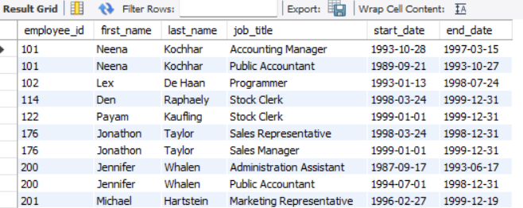

1. How many employees have been with the company for more than five years?

select count(employee_id)as total_employees,job_id from job_history where start_date>= date_sub((select min(start_date) from job_history), interval 5 year) group by job_id;

